Explode Off the Ground: The 8-Week Vertical & Velocity Blueprint
Stop just "working out" and start training for impact. Whether you’re looking to dunk, shave seconds off your sprint, or develop that elite "twitch" that leaves defenders in the dust, our 8-Week Plyometric Power Routine is your roadmap to a more explosive version of yourself.
This isn't a random collection of box jumps. This is a scientifically structured progression designed to turn your muscles into high-tension springs.

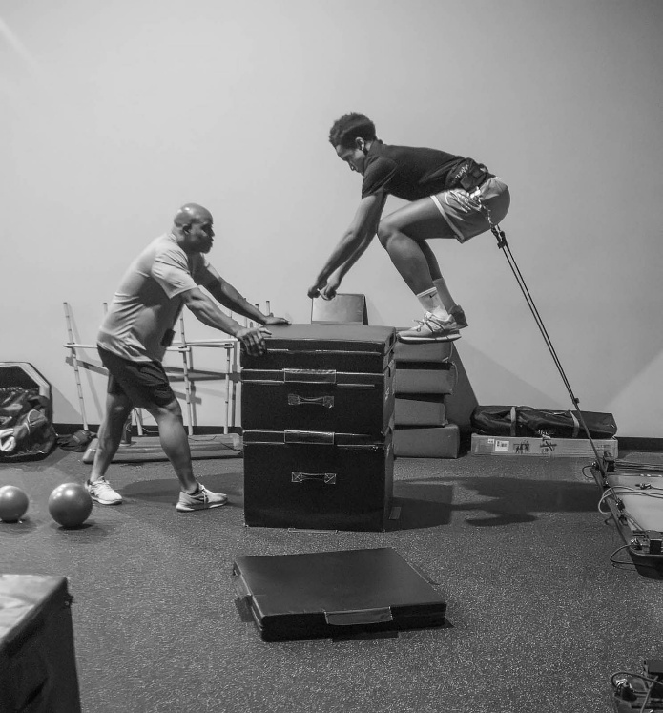

What’s Inside the Program?
We’ve broken the 8 weeks into two distinct phases to ensure you build a foundation before you hit peak output.
- Phase 1: The Foundation (Weeks 1–4)
Focus on eccentric control and landing mechanics. We teach your nervous system how to absorb force so you can redirect it safely and efficiently.
- Phase 2: The Ignition (Weeks 5–8)
We shorten the ground contact time and ramp up the intensity. This phase focuses on the Stretch-Shortening Cycle (SSC) to maximize your reactive power.

Why This Routine Works
- CNS Optimization: Train your brain to fire motor units faster and more synchronously.
- Elastic Energy: Increase the stiffness of your tendons, allowing you to store and release energy like a catapult.
- Injury Resilience: By mastering landing mechanics, you’re not just getting faster—you’re protecting your knees and ankles for the long haul.
- Minimal Equipment: Designed to be done at the gym or the park. If you have a bench, a step, and some space, you’re ready to fly.

The Results You Can Expect
Feature | Benefit
Vertical Leap | Noticeable gains in both standing and approach jumps.
First-Step Quickness | Improved acceleration and lateral cutting speed.
Power Output | Higher peak force production for lifting and sprinting.
Efficiency | Move more fluidly with less wasted energy.

"Plyometrics are the bridge between raw strength and actual athleticism. If you aren't training your 'bounce,' you're leaving half your potential on the table."
Are you ready to take off?
Don't just chase the burn—chase the flight. Grab the 8-Week Plyometric Power Routine today and start moving like the athlete you were meant to be.

Cost: $80

